**To:** **Dr. David Willy; Travis Harrison**

**From:**  **Northrop Grumman Capstone Team**

**Date:**  **1-26-24**

**Re:**  **Engineering Model Summary**

**Top Level Design Summary**

Northrop Grumman Space Systems initiated a project aimed at developing a robotic drilling arm capable of precisely locating drilling positions on any cylinder, crucial for assembling their launch vehicles. The drilling arm must account for varying cylinder sizes and materials while ensuring it can generate enough force to penetrate the targeted composite material, specifically aluminum in this instance. The Northern Arizona University (NAU) Drill Arm team’s solution lies in a unique solution, displayed below in Figure 1.

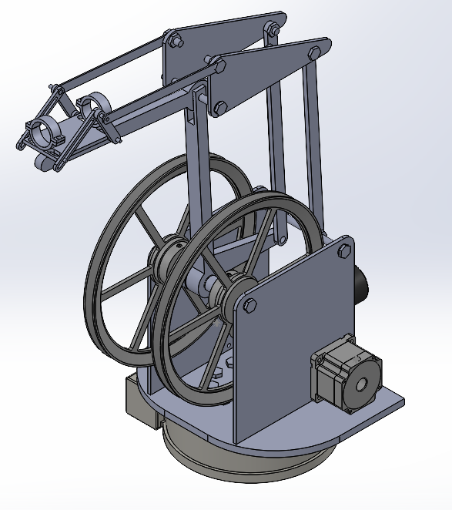

Spindle Subsystem

Base System

Stepper Motors

Driving System

***Figure 1: Current CAD Design***

The four main subsystems (composed of the spindle, driving, stepper motors, and base) make up the product as a whole. The spindle system is composed of the spindle mount, spindle, upper shank, and upper linkages shown on the upper quarter of the product, alongside any miscellaneous electronics and electrical components required to power the components. This subsystem will be responsible for ensuring that the product fulfills its function as a drill and rotates the drill bit via the installed spindle with the appropriate amount of stability included. The driving system is made up of the pulley wheels, belts, and miscellaneous electrical components, which enable the drill arm to be extended forward. Eventually, this system will be folded into a gearbox setup through future redesign efforts. The stepper motors system is made up of the stepper motors and any necessary electrical components. The purpose of this system is to control the pulleys with great precision. Finally, the base system is made up of housing and the slewing drive. The base system is responsible for the rotation of the entire product on the z-axis. These are the primary subsystems of the drill arm as of the time of writing.

**House of Quality**

The House of Quality (HoQ) is displayed below in Figure 2 as a foundational concept in the Quality Function Deployment (QFD) methodology, a structured approach to product design and development. The House of Quality visually represents how customer requirements relate to specific design attributes or features of a product. Its structure, resembling a house, consists of several components: the customer's needs or "whats" on the vertical side, the product's technical requirements or "hows" on the horizontal side, and a matrix in the middle showing the relationship between the two. The "roof" of the house represents the interactions between technical requirements, and the "foundation" or the bottom part often includes benchmarking against competitors. The objective of the House of Quality is to ensure that the voice of the customer is systematically and comprehensively translated into the design of a product or service, thereby enhancing customer satisfaction and minimizing design iterations.

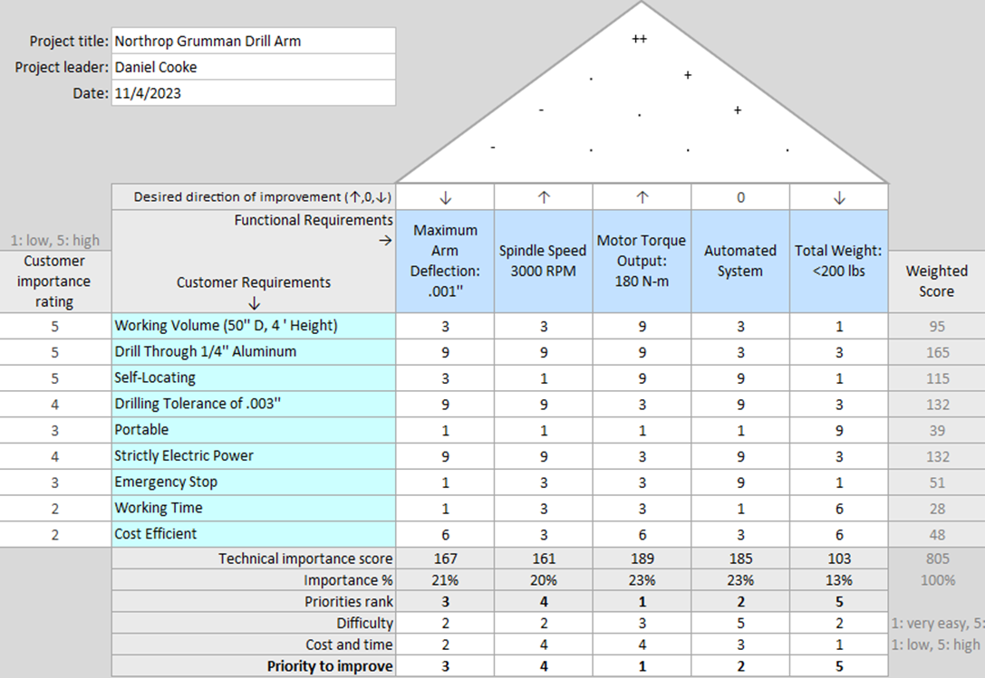

***Figure 2: House of Quality***

The updated house of quality depicts changes in the functional requirements associated with the project. From the engineering calculations, the team was able to compute the necessary minimum functional outputs for the minimum viable product. Given the drilling tolerance of .003’’, it was determined that the maximum allowed deflection during the drilling operation should be .001’’ to allow for more error with the spindle. From research it was determined that the optimal drilling speed through quarter inch thick aluminum is 3000 rotations per minute. Given the predicted weight of the arm along with a maximum spindle weight of 22 pounds, the required torque output from the stepper motors is 180 N-m. This will only be achievable with a gear box of 9:1 gear reduction. The entire system will need to be portable and capable of being locked into placed prior to the drilling operation. It is assumed that it will be able to be rolled into the desired location by no more than two people, and therefore it should weigh no more than 200 pounds total. At the bottom of the QFD it can be seen that the largest priority of improvement is the motor torque output. If the motors are unable to hold the robot arm, let alone move it vertically in its most extended state, no other function is achievable. The second most important function is the automated system. The main idea of the project is to develop a self-locating robotic arm, prior to making it capable of drilling, so this is an essential function. Outside of the slewing drive, the costliest components of this project will be the motors and the spindle to achieve these desired functional requirements.

**Essential Customer Requirements**

Below is a list of the defined customer requirements as determined by both the team and the client working unanimously.

1. Drilling end effector must reach a maximum diameter of 50 inches and a maximum height of four feet.

This is the maximum size cylinder that the drill will be used for. It was discussed during a client meeting that the minimum diameter may be 40 inches, with a minimum height of two feet. However, the main goal is to reach the original work volume as explicitly stated in the client meeting.

1. Drill must be able to drill through a composite material equivalent to ¼ ‘’ aluminum at an angle perpendicular to the surface.

The real product will be drilling through a carbon-fiber composite material, however for the purposes of this project, the clients stated that the team could use ¼’’ aluminum for design tests.

1. Drill must be self-locating.

It is expected that a technician will be able to send the hole locations to the drilling hardware. The drill will then be able to drill the exact number of holes at an exact location without any further intervention from the technician.

1. Entire drilling apparatus must be portable.

A two-man team of technicians must be able to roll the drill to a desired manufacturing location where the cylinder will be dropped in around it before the drilling operation.

1. Drill must have an emergency stop override function (e-stop).

In an event where the machine overheats or experiences any other catastrophic failure, it must be capable of shutting down without the need for human intervention.

1. Drill must run strictly on electric power.

The drill will not have access to hydraulic lines; therefore, it should only run on a standard household appliance power supply.

1. Drill must be able to work continuously throughout a 10-hour day without maintenance.
2. Entire project cost must fall within the $5,000 budget, with the opportunity to increase to $10,000.

The stated budget for the project is $5,000, however if the client considers it to be beneficial to the team, the budget will increase to as much as $10,000.

**Non-essential Customer Requirements**

1. End effector should have multiple drill bits for different job types.

Various jobs will require different sized holes, therefore requiring different drill bits.

1. Drill should be capable of drilling in various directions, on varying surfaces, including flat plates or on the interior of a cone.

It is the goal of the clients to implement the technology developed within this project for more extensive jobs, like flat plates and conical surfaces.

1. User interface with preprogrammed settings for known jobs.

Ideally, a technician would be able to use a digital interface that would allow for a preprogrammed setting to be selected. However, it is likely that the G-code would be sent from a laptop to the robot prior to job execution.

**Engineering Requirements**

Below is a list of the engineering requirements as determined by the team with input from the client.

1. Drilling must meet a minimum tolerance of .003 inches.
2. The drill must not exceed a maximum deflection of more than .001 inches at the tip of the end effector.
3. The drill or spindle must spin at a minimum of 3000 rotations per minute.
4. The drill must apply 153 N-m of torque.
5. The end effector must push the drill bit against the drilling surface with a minimum force of x lbs.
6. The joint motors must be able to supply 180 N-m of torque.
7. The motor holding torque must be 150 N-m with the gearbox included.
8. The slewing drive must have a range of motion of 360 degrees.
9. The joint motors must have a range of motion of 180 degrees.
10. Entire portable assembly must weigh no more than 250 pounds.
11. Entire assembly must cost less than $5,000 (possibly $10,000)
12. Drill bits must be able to withstand 10 jobs per day before replacement.
13. All other robot arm elements and hardware must be able to withstand 100 total jobs before replacement or routine maintenance.

**Summary of Standards, Codes, and Regulations**

The following standards are applicable to the project. If any more standards are discovered or become necessary to rely upon, they will be added in later updates to this summary document.

**ISO 2768 1 & 2 – General Tolerances**

This standard shows general standard metric tolerances for manufacturing use. It will be applied when machining the aluminum parts for the final design using CNC machining, for the precision requirements. The tolerances for linear and angular dimensions were defined as fine, medium, coarse, and very coarse [1].

**ISO 5468:2017 – Rotary and rotary impact masonry drill bits with hard-metal tips**

This standard shows the dimensions and tolerance for drill bits with hard-metal tips. It will be applied during the process of determining the appropriate drill bits to be used during the drill process. The categories for drill bits include short, long, and extra-long bits [2].

**Summary of Equations and Solutions**

**Factor of Safety for Drill Arm Upper Shank: Isaiah Padilla**

The drill arm’s upper shank piece is one of the critical pieces within the entire build, being a major supporting member for the spindle mount itself. In order to determine what the factor of safety for the drill arm’s upper shank would be, the following calculations were carried out. These calculations will focus on determining the bending moment, shear force, bending stress, and factor of safety for the arm itself. These are essential to the project as they will greatly help the team understand the parameters in which any other calculations and manufacturing must be performed. They will also provide critical information on how much force the arm can withstand and the degree to which certain members must be designed to avoid failure.

The following assumptions will be made with regards to the drill arm. All components which will be analyzed are to be made out of 6061 aluminum alloy. This is because 6061 is a commonly used engineering material due to its high modulus of elasticity. This will prove to be an excellent advantage due to the drill arm’s need for a material which will greatly resist deformation when compressed. At this point in time, the exact tempering of the alloy has yet to be decided upon, so for the purposes of this assignment, the T6 tempered alloy will be used and referenced. The following material properties have been obtained from a reputable engineering source [3] and are as follows:

|  |  |  |  |  |  |
| --- | --- | --- | --- | --- | --- |
| Aluminum Alloy | Temper | Elastic Modulus  (E, GPa) | Shear Modulus (G, GPa) | Yield Strength ($σ_{y}$, MPa) | Tensile Strength  ($σ_{u}$, MPa) |
| 6061 | T6 | 10.0 | 3.80 | 35 | 42 |

***Table 1: Aluminum 6061 Material Properties [1]***

The following image in Figure 3 below represents the current CAD state of the product. This will be referenced for all calculations. Simplifications will be made if necessary.

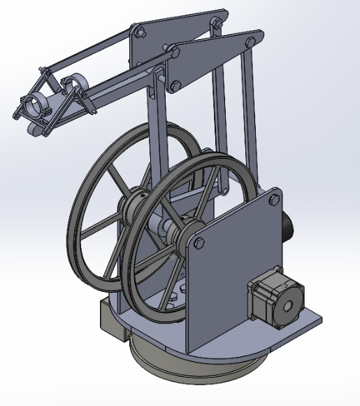

***Figure 3: Current Prototype 2***

Additionally, since the prototype at this time has been specifically designed to be upscaled in order to be used as the full-scale product, the values in the following calculations will reflect a variable to be scaled by the approximate amount by which the actual model is to be upscaled as well. Finally, all calculations will reflect an ideal environment with no attention to the deformation of materials over time, as that is beyond the scope of this particular analysis effort.

In order to calculate the factor of safety for the main member of the drill arm (referred to as the lower shank) which supports the spindle mount (shown with an arrow in the below figure), several other equations will be needed first in order to complete the calculations.



***Figure 4: Lower Shank Member***

The following drawing shows the dimensions for this lower shank member. Note: The upper and lower shank members share the same design, so a single file was created to be used for both parts. The drawing for the upper shank is referenced below, but also counts as the lower shank simultaneously.

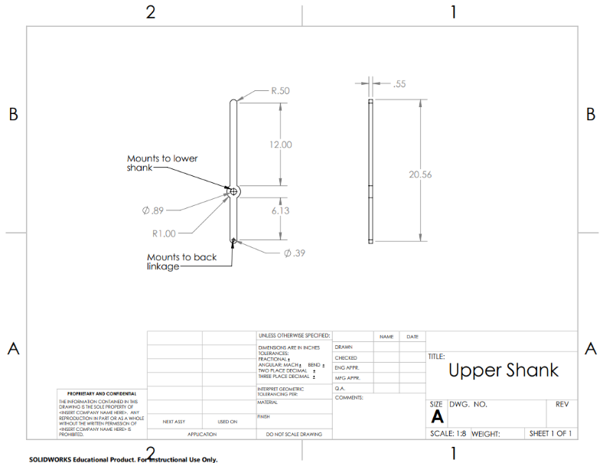

***Figure 5: Upper Shank CAD Drawing***

The first calculation needed to find the factor of safety for the lower shank member is the moment about this member. This will be calculated about the drill bit in order to determine approximately how much rotational force will be applied to the lower shank, as it is directly bolted to the spindle mount. All equations are sourced from *Shigley’s Mechanical Engineering Design* [4]. The equation for the bending moment is as follows:

$$M=P×l$$

Where l is the lower shank length and P is the drilling force. In order to obtain the drill force, the team will assign a variable to P as the force will typically vary according to the thickness of the material being drilled through and well as the material type. For the purposes of this analysis, P will equal about 10 Newtons in the negative y direction (straight down on the tip of the lower shank). For the shank length, the drawing can be referenced above in Figure 3. This comes out to 12 inches from the bolt hole on one end to bolt hole in the middle, or approximately 0.3048 meters. Thus,

$$M=(0.3048 m)×(10 N)$$

$$M=3.048 N*m$$

Next, the bending stress ($σ_{b}$) equation needs to be calculated, the equation for which is shown below.

$$σ_{b}=\frac{M×c}{I}$$

Where c is the distance from the neutral axis to the outermost fiber and I is the moment of inertia. For a rectangular cross section, the moment of inertia is shown to be:

$$I=\frac{bh^{3}}{12}$$

From Figure 3, the base length is determined to be equal to 0.55 inches, or 0.01397 meters. The height is shown to be 1 inch tall, or 0.0254 meter. As such, these values can be substituted into the equation down below:

$$I=\frac{(0.01397 m)*{(0.0254 m)}^{3}}{12}$$

$$I=1.9077*{10}^{-8} m^{4}$$

For the purposes of this analysis, c will equal the half of the height of the lower shank, which would be 0.5 inch, or 0.0127 meter. Therefore,

$$σ_{b}=\frac{\left(3.048 N*m\right)×(0.0127 m)}{(1.9077*{10}^{-8} m^{4})}$$

$$σ_{b}=2.029*{10}^{6}\frac{N}{m^{2}}$$

Finally, the Factor of Safety for the lower shank can be calculated with the following equation.

$$FOS=\frac{Material Strength}{σ_{b}}$$

Since all other values have been obtained, Table 1 can be referenced to obtain the material’s yield strength of 35 MPa.

$$FOS=\frac{35*{10}^{6} Pa}{2.029*{10}^{6} Pa}$$

$$FOS=17.25$$

**Slewing Drive and Speed Output: Mica Nellis**

For the analysis of slewing drives information regarding motor selection, rotations per minute (RPM) output, as well as the necessary mathematical equations. The drive has to be locked into place on the base will rotating all mechanisms above it 360 degrees. Slewing drives historically move extremely slow which is no problem within this design although the team wants to know just how much power needs to be pushed into the drive to get an appropriate number of RPMs from the slewing drive itself. The choice of slewing drive since previous calculations has fallen through although the other options the team is looking into have nearly identical specifications as the previously chosen WEA7 work driven slewing drive. Therefor all calculations will be based on the WEA7 while the choice of slewing drive may be changed to the WE7 which is essentially the same product form a different company. The slewing drive specifications are listed below [5]:

$Output Torque=3.5 kN*m$

$Tilting Moment=13.5 kN*m$

$Holding Torque=20 kN*m$

$Static Axial Load=210 kN$

$Static Radial Load=85 kN$

$Dynamic Axial Load=60 kN$

$Dynamic Radial Load=45 kN$

$Gear Ratio:47:1$

$Tracking Precision≤ .15 Degrees$

$Unit Weight=35.02 kg$

These specifications weighed heavily on the decision of this slewing drive, although the output torque will play the most important role within the upcoming calculations. The amount of speed in RPM’s that the entire base will receive relies on the code that this robot will have implemented within it. It is important to consider the amount of time it will take for the entire robot to reach a certain point before even beginning to drill. Using the governing equations seen below as well as the different specifications found on various motors, also seen below in Figure 6 a code was written to show the speed at which each motor would allow the slewing drive to rotate.

$$Torque \left(T\right)=\frac{Power\left(P\right)*60}{2π\left(RPM\right)}$$

$$Speed=\frac{P*60}{2π*T}$$

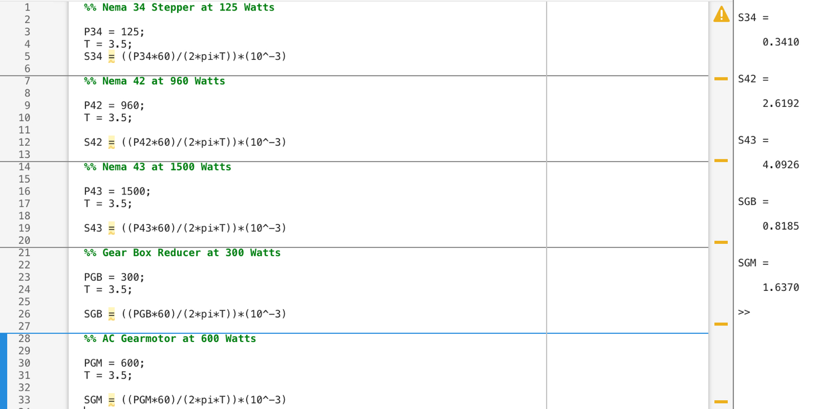 ***Figure 6: Code for RPM outputted from motors.***

As shown above the Nema 43 stepper motor with 1500 watts will give us the highest and most appropriate speed for the tasks that this robotic drilling arm will need to perform. This is extremely slow and no matter the code there will be a small delay in the communication between the motor and the slewing drive; this means that when the motor stops the slewing drive has a potential to continue movement for slightly longer, which can cause major issues given the expected precision of this design. Since this can cause such catastrophic problems, the team will likely implement a gearbox in between the motor and slewing drive to have accurate and precise communication.

**Gear Ratio Analysis: Russel Stringham**

The goal of this analysis was to give the team a better understanding of the various gear ratios the team can achieve based on the number of and size of the pulleys to create a higher torque output. If the torque is not high enough, the robot cannot accurately move to and hold the desired location. The calculations were done on Nema 34 Stepper motors, EG Series Planetary Gearbox, and various V-Belt Pulleys. The equations listed below were used to make calculations for the gear ratios for the pulleys. The current design includes a two-pulley system that is attached to the gear box. The results when changing the outer diameter of the second pulley show that the higher outer diameter will output the highest gear ratio. The highest gear ratio with a 2.05-inch pulley and the largest pulley that fits the system (13.75 inches) was 302:1. These results were then compared to a three-gear system. The first two pulleys were set to 2.05 inches and 4.05 inches. When increasing the third pulley that results showed a 13.75-inch pulley will output a gear ratio of 302:1. The results are also shown in the charts below. Based on all the results, it will not matter if the team decides on a two or three-gear system, the output gear ratio will be similar. If the team decides the 13.75-inch pulley is too big, a three-gear system will be best. This is because the increasing the second pulley and decrease the third pulley will still output a similar result. Overall, the two-pulley system will be the most cost effective and easiest to assemble system for the robotic arm.

Equations:

Two Pulley System:

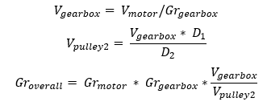

Three Pulley System:

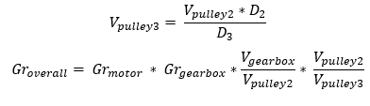

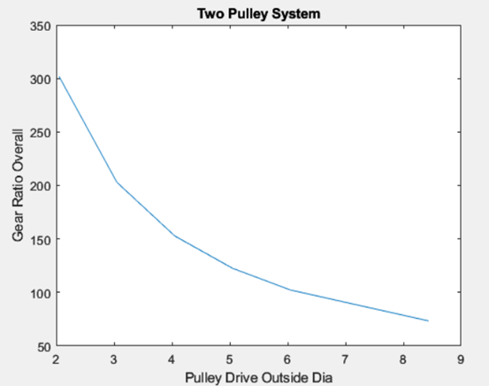

***Figure 7: Two Pulley System***

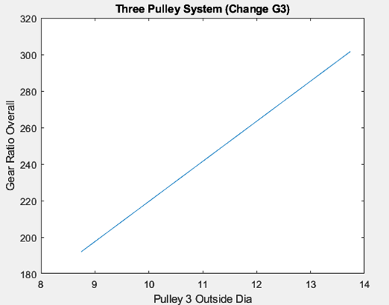

***Figure 8: Three Pulley System, Changing G3***

**Power Transfer Mechanism for Upper and Lower Shanks: Brandon Knutson**

Beginning with research into common power transfer methods the team found several reasonable options that could handle the high Torque requirements of this design. The first two were the worm gear and the planetary gear designed devices. After looking at several websites it was found that they both seemed to specialize in one or the other of these two designs. The only issue with these these choices were a combination of size, cost capability and weight. For the worm gear designs, most applications could handle torques well exceeding what was required for this project, raising the starting prices to a little over one thousand dollars and having the starting weight being 45 pounds. As for the planetary gear boxes, the team had an exceptionally tough time finding gearboxes that could handle the torque requirements without them having weeklong waiting lists and the requirements for quotes which has been have tough getting since the beginning of this course.

This leaves the team with the options of belt and chain driven systems. Following this it was decided that a belt operated system would be easier to construct and lighter. It was assumed that upon the unlikely event of rapid self-disassembly that the belt driven system would require a less robust shielding system than a chain driven alternative. From this decision it was a brief list of operations to find that the team needs a 2 and 4 stage gear box system to operate the lower and upper shank. First using the known maximum torque requirements and speed for the system, 250 Newton meters and 3 radians per second. The system would only be exerting what would be equivalent to 1.006 Horsepower. Knowing this the team could go to the machinist's handbook and find that for this application a 3VX type belt would be required. Knowing this the team went to McMaster-Carr and found that there was only one available pulley with a maximum and minimum diameter sizes of 3.35 and 5 inches. Using these maximum and minimum pulleys a single stage can produce a 49% increase in torque, multiplying these stages together the lower shank will need a 4-stage belt system creating a 1 to 4.96 gear ration and a s stage system creating a 1 to 2.23 ration to produce the required output torques. As for assembly of these two gearboxes, they will consist of an aluminum support structure on both sides of the pulley shafts with a sheet metal enclosure. The shafts will be solid and will not rotate for the pulleys will have bearing press fit into them and will be held in place of the shaft by C clips. One of the shafts will have an adjustment screw what will allow for at least an inch of adjustment to the belts as they stretch over time. These assemblies will then be bolted to the base plate via the aluminum support structures and will have two connection collars on both the input and output shaft.

**Main Member Deflection: Daniel Cooke**

In order to ensure that the maximum drilling tolerance of .003’’ is met, it was determined that the maximum allowed deflection for the end effector should be .001 inches off of the axis of drilling. This takes into consideration the material the main members are being constructed out of, as well as the shape and dimensions of those main members. The members most likely to incur deflection are the three vertical beams that translate motion to the end effector. These members will be manufactured from 1’’x1/8’’ aluminum square tube. This engineering analysis considers the deflection of aluminum square tube under various static loading, as well as what kind of reinforcements must be implemented. The given forces acting on this system are the weight of the spindle, spindle mount, lower shank, tri-plates, and hardware. A 30-pound reaction force during the drilling operation will also impact the deflection of the main members. All given data for the analysis can be seen below in Table 2.

***Table 2: Given Beam Parameters***

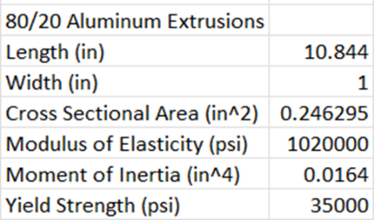

Beam Deflection Equation

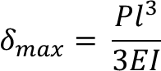

P = 50lbs

$$δ_{max}= .1294 in$$

Note that this calculation was performed on only a single beam as opposed to all three beams. Also, the load will not be acting directly perpendicular to the beam. In order to determine the true deflection of the entire system, a complex finite element analysis (FEA) must be performed on the entire CAD model. Previous iterations of the design were tested in a FEA and the maximum deflection of the end effector was determined to be .00147 inches. It is expected to have similar if not better results with the current design. The analysis also shows that there will be significant need for reinforcements to prevent lateral movement and increase stability during the drilling operation.

**Load Cases and Factors of Safety**

Currently the only load cases done for the system are for the linkages that comprise a large percent of the supporting structure that allows the geometric system to operate, these components are simple and will only consist of a compressive load assumed to be less than 100 pounds. Under such conditions the structures see such minor deflection it resides under a thousandths of an inch of displacement. If, however, the load case is found to not be compressive and is in fact as little as five degrees off center, it will cause deflection that will severely affect the system's performance. As for the other components, they are built so robustly as to carry most of the case load that no rigorous analysis has been done on them so far. This work will be continued with SolidWorks integrated simulation software for ease of use and visual demonstrations for load cases.

The factors of safety are still being worked through by the team currently although for the overall design it is know what will likely affect the functionality the most. It can be seen below within table three the highlighted portions will likely cause the most concern going further, the drill bit, the slewing drive, and all vertical members. These portions of the design will be extremely important going forward because they will have to withstand the most force and load throughout performance. Although these different parts within the design are cause for high concern the team is prepared for these factors of safety that will be extremely low by having very rigid structure. Within table three the highlighted factor of safety of 17.25 for the lower shank within the spindle mount is going to be carefully articulated even though the factor of safety is very high, the load put onto this member is extremely vital in the overall accuracy of drilling. Although the factor of safety table is not as thorough as the team had hoped at this stage the team is working on calculating these values as soon as possible in hopes of having a better made and well planned design.

|  |  |  |  |  |
| --- | --- | --- | --- | --- |
| Sub-system | Part | Load Case Scenario | Material | Minimum FoS |
| Spindle Mount |  |  |  |  |
|  | Lower Shank | Applied load from horizontal drilling motion value (TBD), as well as bending stress and compression. | Al 6061 | 17.25 |
|  | Slide Shank | Horizontal load from linkages located behind shaft. | Al 6061 |  |
|  | Drill Bit | Applied load from horizontals drilling. | Cobalt |  |
|  | Spindle Peg | Bending stress from tension and compression | Al 6061 |  |
| Stepper Motors |  |  |  |  |
|  | All Motors | Torsional Load |  |  |
| Base |  |  |  |  |
|  | Base Plate | Horizontal Load from drilling motion | Al 6061 |  |
|  | Slewing Drive | Torsional load from motor, and axial load from weight all weight above |  |  |
| Robot Body |  |  |  |  |
|  | All Vertical Members | Horizontal load from drilling motion, and weight from members holding up spindle mechanism | Al 6061 |  |

***Table 3: Factor of Safety Table***

**Flow Charts and Other Diagrams**

**Control Flow Chart – Daniel Cooke & Mason Goodman**

The control flow chart is an essential diagram that depicts how the electrical input energy will be converted into the movement of the robotic arm. In order to precisely control the motor movement, several electrical components must be integrated into the system. The control flow chart can be seen below in Figure x: Control Flow Chart.

The robot will be powered by a 30-volt DC power supply that will split power between the 12 and five volt converters. The 12-volt converter will directly power the stepper drivers which will control the movement of the two stepper drivers and the slewing drive. The limit switches will be supplemented with the microcontroller to define the limit of travel of the motors. The five-volt converter supplies both the microcontroller and the Arduino board, which takes the g-code from a computer source and tells the motors how far and fast to rotate. The drilling spindle will be controlled by the Variable Frequency Drive that determines the rotational speed of the spindle for different drilling applications. The Arduino board will determine when the spindle activates. The Arduino board will also directly control the movement of the wrist stepper that will actuate the spindle.

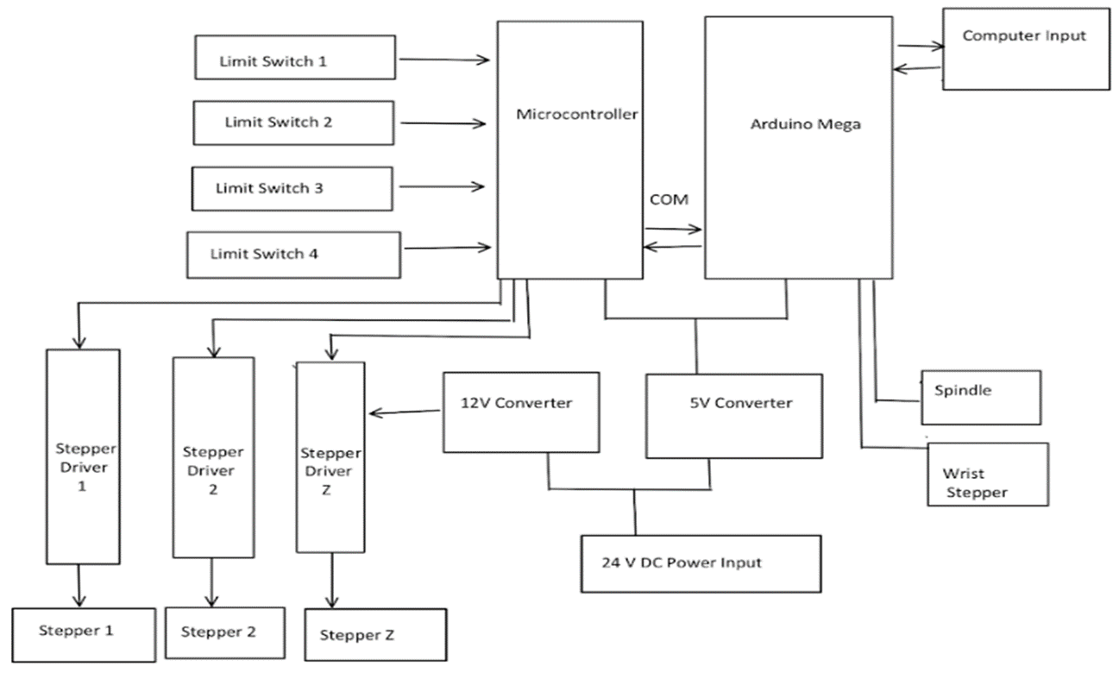

***Figure 9: Control Flow Chart***

The substantial issue with circuit design is the potential for surges of maximum current that will surpass what is readily available for arm prototyping. The most common electrical outlet typically found in a home or office is 110-Volt and 15-Amp [13]. Additionally, as a rule of thumb for typical outlets, it is safest to adhere to a maximum load of 1,500-Watts [14]. The CNC spindle motor alone requires 1.5-Kilowatt (1,500-Watt) power source to run drilling operations. Based on specification tables previously assessed in the report, the maximum amperage pulls the design can require is 19.68-Amps for a complete maximum load. Circuit breakers that protect wall outlets, can only handle about 80% of their overall amperage [14]. That means a 15-amp circuit breaker can handle around 12-amps and a 20-amp circuit breaker can handle about 16 amps [13]. Therefore, for safe prototype testing the Capstone Team would require a 220-Volt and 30-Amp circuit that is meant for applications that the demand highest commercial electricity provided in a home [13].

An additional piece of equipment previously unaccounted for in final design consideration is a Variable Frequency Drive (“VFD”). VFD’s or spindle inverters, take power from the wall and create a frequency with voltage and current to spin the spindle [15]. The frequency can be controlled to control the RPM of the spindle for different drilling applications [5]. Thus, a VFD is required for the articulating arm’s finalized design to control the spindle RPM for different drilling material.

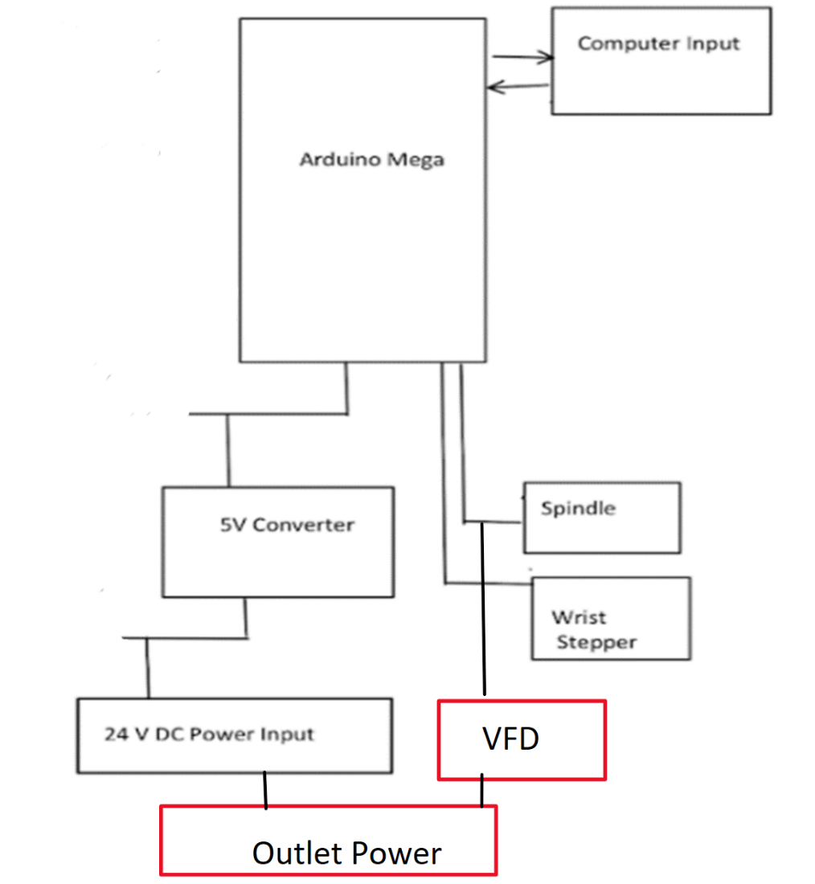

Figure 10: Additional Circuit Equipment

**Moving Forward**

Going forward in this semester the team hopes to have more information in regard to the load cases, factors of safety, slewing drive, and the overall operations of movement on this design.

Although, there has been several load analyses completed within SolidWorks throughout this entire design process many of them were completed using previous CAD. The team has taken deeper looks into the deflection due to the weight the horizontal “reaching” component of the design, but there are many different load factors that should be completed using FMEA going further. It can be seen throughout this modeling summary all design choices, load factor studies, and purchase choices show impactful to the customer requirement of accuracy during drilling. These different load factors that need to be further analyzed will likely be most impactful on the accuracy component therefore the team plans to calculate and model the necessary members with the final CAD not being completed.

All factors of safety need to be considered going forward, the team has been focused on purchasing plans as well as finalizing design before determining these different factors of safety. With this being said given the high number of torsional loads all throughout the system there will be important factors of safety going forward in hopes that the team can plan for each of these loads at any given location to prevent catastrophic failures. There will also be a certain amount of horizontal loading once the drilling motion is started and this motion will affect everything within the system, if there is not proper building at the base of this design it will likely cause the design to stray away from the point of drilling causing inaccuracy of the tolerances previously calculated. The drilling motion will also cause all members within the design to shift if they are not locked into place by welding or bolting together, therefor these members will need to be extremely rigid to withstand the amount of load put onto them. After compiling the beginnings of this factor of safety table the team cannot be sure how this information will impact the overall design and will derive that information within the coming few weeks. In order to gain a better understanding of the stresses and deflection on the robot during the drilling process, a more in depth finite element analysis will be performed on the current CAD model.

The calculations of the slewing drive within this report are based on the previously chose WEA7 slewing drive that the team had decided on but due to extremely long shipping times the choice of slewing drive is changing going forward. Although these calculations were run on the WEA7 spec sheets the new choice of slewing drive values are nearly identical to those of the WEA7 slewing drive. If the team is able to get the newly chosen slewing drive these calculations will likely stay the same as well as the motor choice to power the device, despite this the calculations will need to be rerun because the slight changes will impact the overall performance of the design.

Northrop Grumman wants this system to be fully autonomous and the team had just begun breaking through all of the necessities of this at the end of the last semester, all members of the team are hoping to have more knowledge going forward with reaching this goal of being fully autonomous. Along with this requirement the overall movement of the design will be extremely important, there will need to be smooth and precise to have accurate drilling to not have total failure of the design. Every movement that the design makes will have cause some amount of loading through various different areas of the design each of those will be accounted for within the factor of safety table going forward.

Clearly, the team has many mathematical concepts to consider going forward as well as finding all amounts of deflection, tension, and compression through the entire system. This will impact the overall performance of the design, as previously stated the accuracy of this device is essential. By finding all necessary load factors, factors of safety, slewing drive information, and compiling the overall movement of the design is the most important concepts to find going forward for the team.

**References:**

[1] General Tolerance ISO 2768 1 & 2 . DEKMAKE. Accessed: Jan. 25, 2024. [Online]. Available: https://www.dekmake.com/wp-content/uploads/ISO-2768.pdf

[2] ISO, “Rotary and rotary impact masonry drill bits - Dimensions.” International Standards Organization, Switzerland, Feb. 2017

[3] “Aluminum alloys - mechanical properties,” Engineering ToolBox, https://www.engineeringtoolbox.com/properties-aluminum-pipe-d_1340.html (accessed Dec. 6, 2023).

[4] R. G. Budynas and J. N. Nisbett, “Chapter 3 - Load and Stress Analysis,” in *Shigley’s Mechanical Engineering Design, 11th edition, SI units. (NO US rights)*, 11th ed, New York, NY: MCGRAW-HILL EDUCATION (AS, 2020, pp. 93–171

[5] “Dayton AC Gearmotor, 70 rpm, TEFC, 115/230V 4Z521 | Zoro.” <https://www.zoro.com/dayton-ac-gearmotor-70-rpm-tefc-115230v-4z521/i/G3189891/?recommended=true#specifications>

[6] “Gearbox Reducer Slew Drive Stepper Motor - Buy Gearbox Reducer,Slew Drive Motor,Slew Drive Stepper Motor product on Alibaba.com.” [Online]. Available: <https://www.alibaba.com/product-detail/Gearbox-reducer-slew-drive-stepper-motor_1600083784784.html>

[7] P. & C. Llc. A. R. Reserved, “Worm Gear Slewing Drives: WEA Series - SlewPro.” https://www.slewpro.com/products/slewing-drives/wea-series

[8] "Nema 34 Stepper," Stepperonline, [Online]. Available: https://www.omc-stepperonline.com/nema-34-stepper-bipolar-l-97mm-w-rear-shaft-gear-ratio-9-1-spur-gearbox-34hs38-4004d-sg9. [Accessed 6 December 2023].

[9] “EG Series Planetary Gearbox," Stepperonline, [Online]. Available: https://www.omc-stepperonline.com/eg-series-planetary-gearbox-gear-ratio-5-1-backlash-15arc-min-for-12-7mm-shaft-nema-34-stepper-motor-eg34-g5-d13. [Accessed 6 December 2023].

[10] “Heavy Duty V-Belt Pulleys," McMaster-Carr, [Online]. Available: https://www.mcmaster.com/products/belts/belt-trade-size~ax/belt-trade-size~bx/od~13-75/od~13-3-4/. [Accessed 6 December 2023].

[11] “V-Belt Pulleys," McMaster-Carr, [Online]. Available: https://www.mcmaster.com/products/belts/belt-trade-size~ax/od~2-05/. [Accessed 6 December 2023].

[12] R. G. Budynas and J. K. Nisbett, "Shighley's Mechanical Engineering Design," 11th ed.

[13] Get it right the first time: A how-to guide for matching power outlets ..., https://www.pcrichard.com/get-it-right-the-first-time-a-how-to-guide-for-matching-power-outlets-plugs/Blog-6947.html (accessed Dec. 7, 2023).

[14] A. 29, “Watt’s too much? how much you can you plug into one outlet,” Overloaded Outlet: How Many Things Can I Plug Into One Outlet | HomeServe USA, https://www.homeserve.com/en-us/blog/home-improvement/overloaded-outlet/ (accessed Dec. 6, 2023).

[15] “2.2 kW (kilowatt) water cooled spindle with inverter (VFD),” Build Your CNC - CNC, CNC Router, CNC Router Kits, CNC Machine Kits, Laser Machines, CNC Machine Tools, and CNC Cutting, https://buildyourcnc.com/item/spindle-inverter-2!2kw-spindle-vfd#:~:text=Spindles%20required%20the%20use%20of,the%20RPM%20of%20the%20spindle. (accessed Dec. 6, 2023).